NOTICE OF SPECIAL MEETING

PLEASE POST

Notice is hereby given of a Special Meeting of the Greenwich Public Schools Food Services Committee, to be held on Thursday, October 10, 2019 at 9am at the Havemeyer Building, Board Room at 290 Greenwich Avenue, Greenwich, Connecticut.

The purpose of the Special Meeting is to:
- Finalize October 17, 2019 Board Meeting materials

Those requiring special accommodations to attend the meeting should contact Linda Valentine by phone at 203-625-7486, by email at linda_valentine@greenwich.k12.ct.us, or in person at 290 Greenwich Avenue, Greenwich, CT, at least 72 hours prior to the meeting.

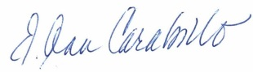
E. Ann Carabillo
Deputy Superintendent, Chair, Food Service Committee

EAC/lv
10/7/19

