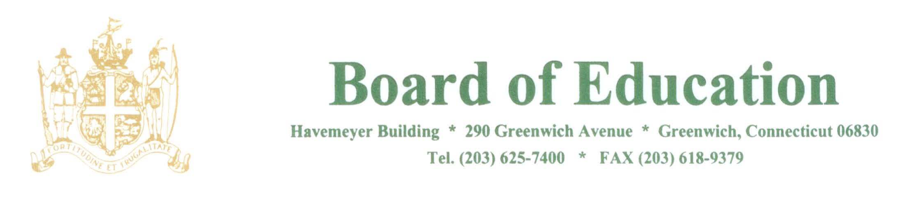

NOTICE OF Change of MEETING Start Time

PLEASE POST

Notice is hereby given that the December 6, 2018 meeting of the Policy Governance Committee of the Greenwich Board of Education, Havemeyer Building, 290 Greenwich Avenue, Greenwich, CT will begin at 11:00am.

The purpose of the meeting is to review policies.

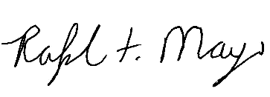
____________________
Mr. Ralph Mayo
Interim Superintendent of Schools

