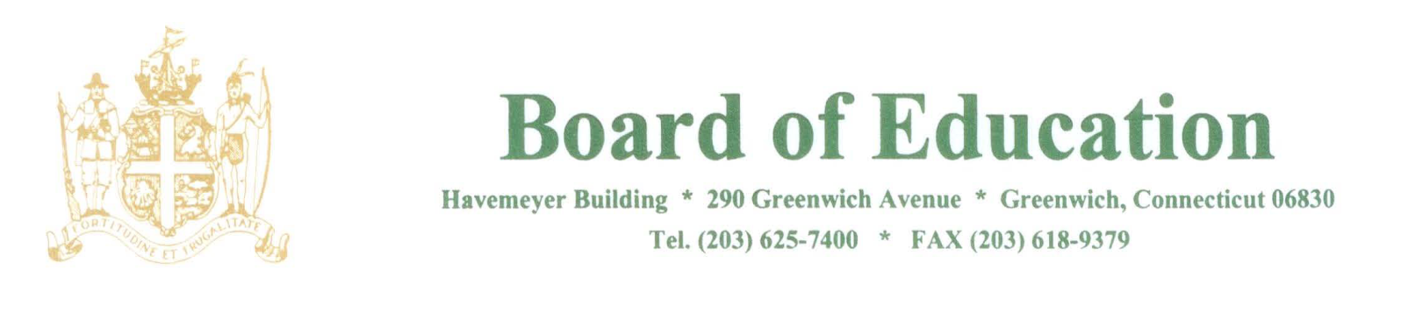

NOTICE OF Change of MEETING Start Time and Location

PLEASE POST

Notice is hereby given that the November 1, 2018 meeting of the Policy Governance Committee of the Greenwich Board of Education has been moved to the PPS Conference Room, Havemeyer Building, 290 Greenwich Avenue, Greenwich, CT and will begin at 12:30pm

The purpose of the meeting is to review policies.

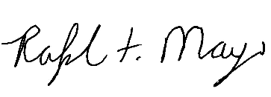
____________________
Mr. Ralph Mayo
Interim Superintendent of Schools

