NOTICE OF CHANGE OF MEETING DATE and START TIME

PLEASE POST

Notice is hereby given for the change of start time of the Meeting of the Board of Education Policy Governance Committee scheduled to be held on Tuesday, October 10 at 6:30pm in the Havemeyer Boardroom. The meeting date and start time has been changed to October 12 at 4:30pm.

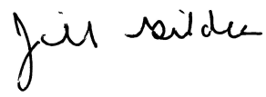
____________________
Dr. Jill Gildea
Superintendent of Schools

