NOTICE OF CHANGE OF MEETING START TIME

PLEASE POST

Notice is hereby given for the change of start time of the Meeting of the Board of Education Policy Governance Committee scheduled to be held on Thursday, September 28 at 6:30pm in the Havemeyer Boardroom. The start time for the meeting has been changed to 5:30pm.

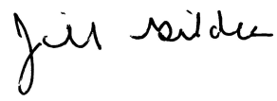
____________________
Dr. Jill Gildea
Superintendent of Schools

