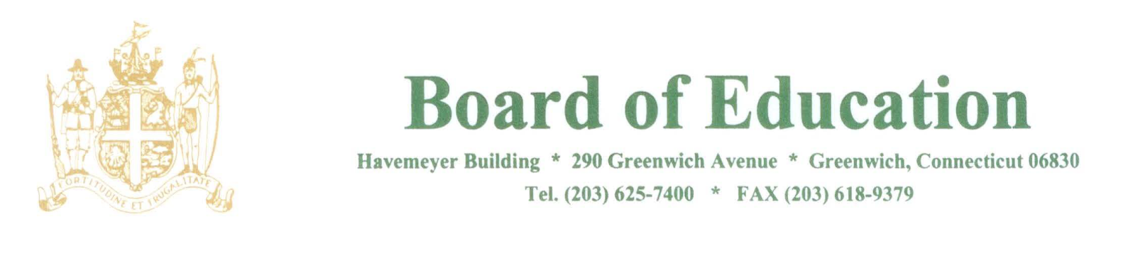

NOTICE OF MEETING

PLEASE POST

Notice is hereby given of the following meeting of the Policy Governance Committee of the Greenwich Board of Education to be held on Tuesday, June 19, 2018 at 1pm in the Havemeyer Boardroom, 290 Greenwich Avenue, Greenwich, CT.

The purpose of the meeting is to review policies.

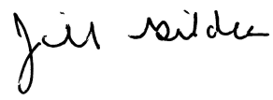
____________________
Dr. Jill Gildea
Superintendent of Schools

