NOTICE OF CHANGE OF MEETING DATE

PLEASE POST

Notice is hereby given for the change of meeting date and start time of the Meeting of the Board of Education Policy Governance Committee scheduled to be held on Thursday, 5/17/18 at 12:30pm in the Havemeyer Boardroom. The meeting date and start time has been changed to Thursday, 5/10/18 at 12:30pm in the Havemeyer Boardroom.

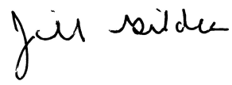
____________________
Dr. Jill Gildea
Superintendent of Schools

