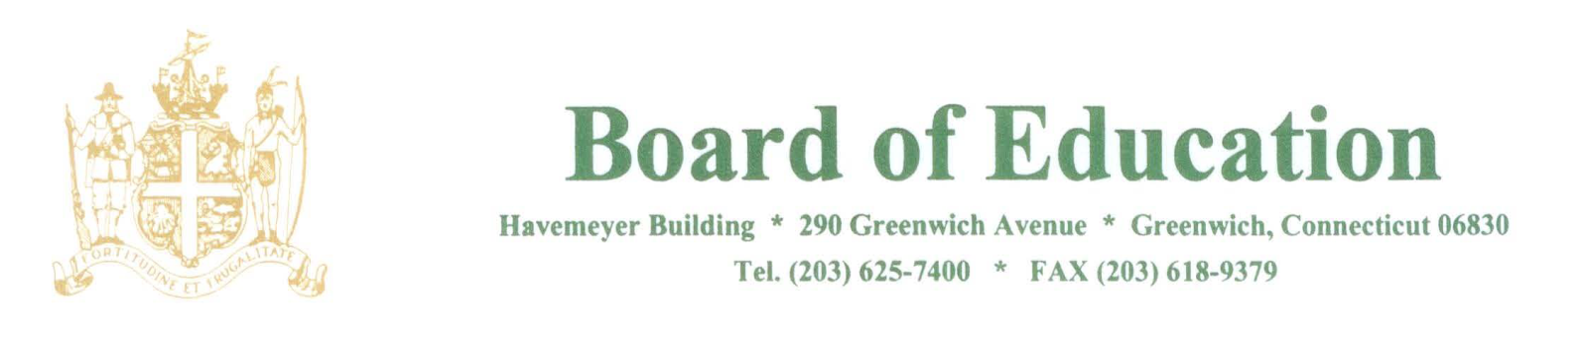

NOTICE OF CANCELATION OF MEETINGS

PLEASE POST

Notice is hereby given of cancelation of the following Meeting of the Board of Education Policy Governance Committee that was scheduled to meet in the Havemeyer Boardroom on Thursday, March 8, 2018 at 12:30pm.

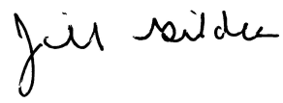
____________________
Dr. Jill Gildea
Superintendent of Schools

JG/lv
3/8/18

