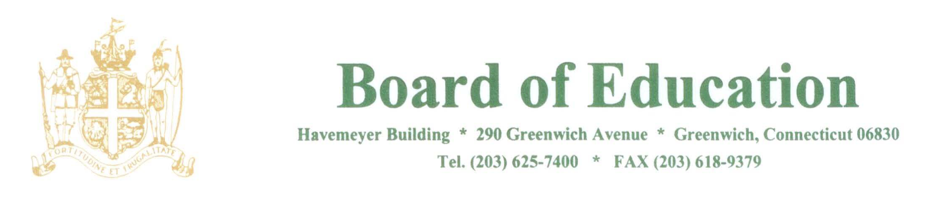

NOTICE OF MEETINGS

PLEASE POST

Notice is hereby given of the following meetings of the Policy Governance Committee of the Greenwich Board of Education. All meetings will be held in the Board Room, Havemeyer Building, 290 Greenwich Avenue, Greenwich, CT.
All meetings will begin at 12:30pm.

1/18/18
2/1/18
2/22/18
3/8/18
3/22/18
4/5/18
4/19/18
5/3/18
5/17/18
5/31/18
6/14/18

The purpose of these meetings is to review policies.

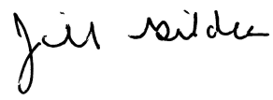
____________________
Dr. Jill Gildea
Superintendent of Schools

JG/lv
1/12/18

