NOTICE OF CHANGE OF MEETING START TIME

PLEASE POST

Notice is hereby given for the change of start time of the Meeting of the Board of Education Policy Governance Committee scheduled to be held on Wednesday, January 25, 2017 at 1:30pm in the Havemeyer Boardroom. The start time for the meeting has been changed to 1:00pm

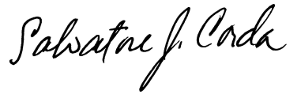
____________________
Dr. Salvatore Corda
Superintendent of Schools

SJC/lv
1/17/17

