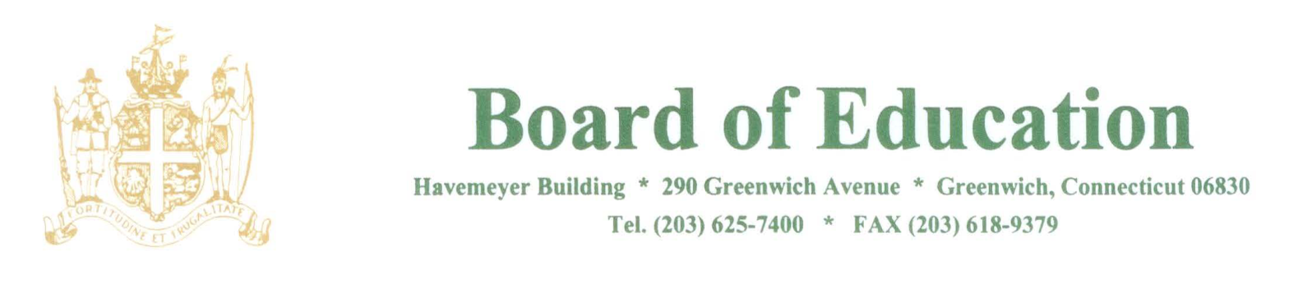

NOTICE OF MEETING

PLEASE POST

Notice is hereby given of the following meetings of the Policy Governance Committee of the Greenwich Board of Education. These meetings will be held in the Board Room, Havemeyer Building, 290 Greenwich Avenue, Greenwich, CT at 12:40pm.

The purpose of the meetings are to review policies.

2019:
9/5
9/26
10/10
10/24
11/7
11/21
12/5
12/12

2020:
1/9
1/23
2/6
3/5
3/19
4/2
4/16
4/30
5/14
5/28
6/11

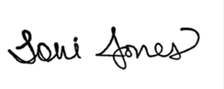
____________________
Dr. Toni Jones
Superintendent of Schools

