RESEARCH STORIES

College and (the Real) You

A new push for authentic community service aims to reframe college admissions. Here's what students should know.
BY:Leah Shafer

POSTED:June 6, 2016
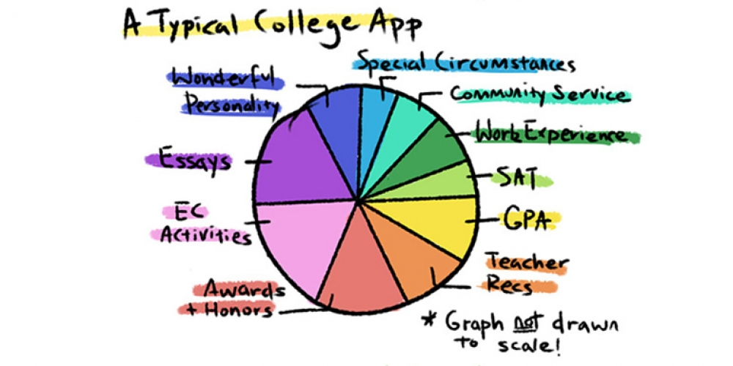
While high school seniors across the country celebrate the end of the college admissions process, juniors, sophomores, and even freshmen may look at the months and years ahead with anxiety and confusion. “Should I join a new club?” they may be asking, as they wonder how to make their college applications stand out. “Take another AP class? Organize a food drive? Run for student council?”
And above all: “What are colleges looking for?”

Turning the Tide
The answer to that question may be shifting, in reaction to what many have seen as a pressure-packed focus on individual achievement. As the competition for admission to top colleges has grown, many parents, schools, and students themselves have emphasized top grades, leadership, and lists of after-school clubs and sports — often at the expense of community service, ethical engagement, and a general focus on caring for others, according to human development expert Richard Weissbourd.
More than 140 key stakeholders in college admissions, including almost 100 college admissions deans, have now endorsed a new report from the Harvard Graduate School of Education that calls for fundamental changes in the admissions process — changes, they hope, that will mitigate the current rivalry, stress, and inauthenticity that accompany many college applications. The report, called Turning the Tide, recommends changes in three main areas:
- An increase in equity and access for economically disadvantaged students
- A reduction of undue academic pressure in high school
- An emphasis on authentic community service and engagement with the public good.
But before teenagers hurry to join as many community service organizations as they can, or rush to establish their own charity, it’s helpful to probe a little deeper into what “authentic service” really means — and what kinds of recommendations high schools and colleges have for teenagers.

What Is "Authentic" Service?
Weissbourd, co-director of the Making Caring Common project that created Turning the Tide, wants families and schools to rethink community service. “We are trying to redefine service so it’s not considered an achievement — it’s considered an experience,” he explains. “Community service has been defined in terms of leadership, in terms of entrepreneurship. We’re saying that’s not really what’s important.”
So what is important? The report suggests that students get involved in authentic service and community engagement that:
- Is meaningful and sustained. Students should be engaging in long-term projects that connect to their own passions and interests.
- Enables them to work on a collective activity that takes on community challenges. When providing community service, students should be learning how to collaborate and problem-solve in groups — and those problems can be close to home, too.
- Includes authentic experiences with diversity. Rather than framing service as “doing for,” students should think of it as “doing with” — as working together with people or communities not only to foster solutions, but also to cultivate bonds across racial, cultural, economic and/or religious differences.
- Involves time and space for intentional reflection and gratitude. Students should use community service as an opportunity to reflect both on the contributions of previous generations and their responsibility to the future.
“Right now, in some communities, there’s a kind of community-service Olympics going on to see who can have the most high-profile service opportunity,” says Weissbourd. But “what’s important is having a meaningful experience. And that can be local. We’re encouraging students to consider working in diverse groups, becoming civically engaged, getting under the hood of their community and understanding how it works, who has power and who doesn’t have power, who’s included, who’s not included.”

Engaging With What's Important to You
So how should high schoolers begin pursing these more meaningful community service opportunities? What kinds of projects should they be looking for?
The first step may be for teenagers to revisit how they spend time after school. Instead of participating in four clubs — two of which a student doesn’t really care about — he might want to take that time to find a service opportunity, says Newton South High School counselor Sarah Style. Turning the Tide emphasizes the importance of quality over quantity in a student's extracurriculars and achievements. Community service shouldn’t just be another line on a laundry list of activities.
Teenagers with important family commitments — babysitting younger siblings after school, working in the family business, caring for an elderly relative — should include those service contributions on their applications. Part of Turning the Tide’s mission is to level the playing field between high-income, privileged students and lower-income students. Teenagers who help to support their families every day do not need to feel pressured to find an additional community service opportunity just to augment their college applications.
For students with fewer prior commitments, Weissbourd suggests that students get involved in issues relevant to their community. They can try working with a team to clean up a community park, collaborating with local government to make the community more environmentally friendly, or starting a campaign to end cyber-bulling in their school. Of course, as Weissbourd explains, more familiar forms of service, like volunteering at a homeless shelter or reading to children, are worthwhile, and international service trips have value, too. But the more a student is personally invested in the work, the more sustainable that work is likely to be.
If they’re still unsure, teenagers should consider service opportunities that overlap with their current interests and pastimes. They should go with their instincts, explains Jonathan Burdick, University of Rochester’s dean of college admission and vice-provost for enrollment initiatives. If they like playing soccer, they should use that enthusiasm to help others enjoy it too — by coaching younger students or refereeing in a league, perhaps. It’s as simple as “finding things they like to do, and thinking about how they can do it in a way that benefits people beyond themselves,” Burdick says.
Above all, says Philip Ballinger, the University of Washington’s associate vice provost for enrollment and undergraduate admissions, students should be intrinsically motivated to pursue their afterschool activities. Students and their parents may not realize it, but universities can usually tell when a student participates in programs with the sole intention of perfecting a college application. Teenagers should view community service not as a requirement, but as an opportunity — one that they have the freedom to shape.

