Greenwich Public Schools Parent Portal – New User Registration

**STEP 1: Access the Parent Portal**

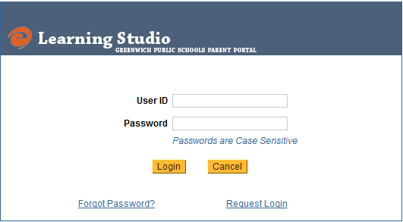To create a Parent Login account, go to <https://parent.gsdteacherportal.com>

You will be presented with the User Login page.

Select the Request Login link to begin the registration process.

**STEP 2: Have Student Profile Information Handy**

Before you begin the registration process please have your Student Profile Sheet handy to enter the information about your children.

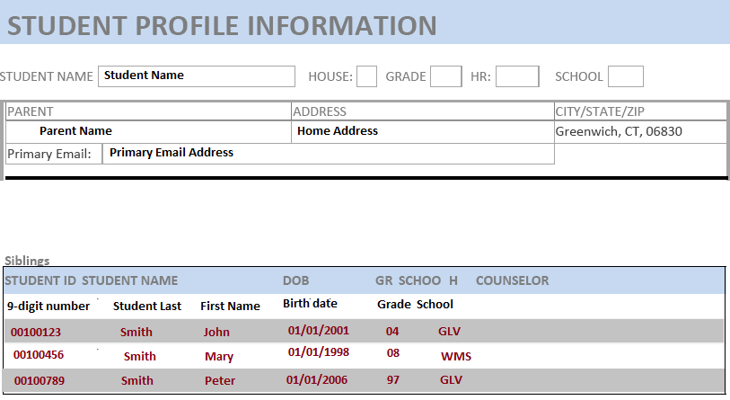

A sample ***Student Profile Information*** is located to the right.

The information required for initial login are highlighted in red.

Login Information:

**Primary Email address**, **Number of Students,**

**Student ID** – 9-digit number for each student

**Student Name** as it appears on this form, **Student Date of Birth**, **Student Grade**, **Student School**

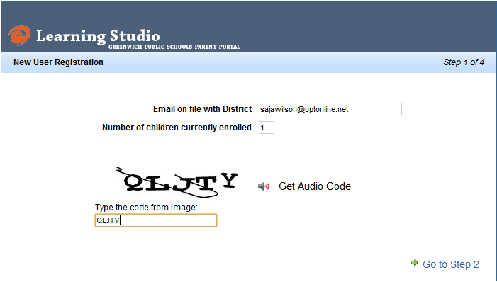**STEP 3: Add your User Information**

**Initial Login Screen**

Primary Email Address

Number of children currently enrolled

Enter the CAPTCHA provided on the screen exactly as it appears on the screen. In this example, QLJTY,

You may click the *Get Audio Code* to hear the code rather than read the code.

Click the Go to Step 2 link in the lower right corner once you have completed the above process

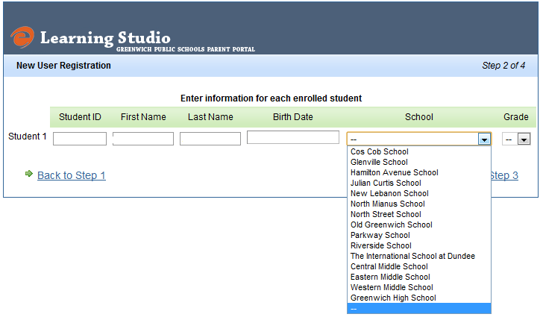

**STEP 4:** **Enter information as it appears on the student profile.**

1. You will see student entries for the number of students your entered in Step 1. (in this example we listed 1 student)
2. For each student, enter the 9-digit student ID, First Name, Last Name, Date of Birth, Select School from the drop-down list, and select grade from the 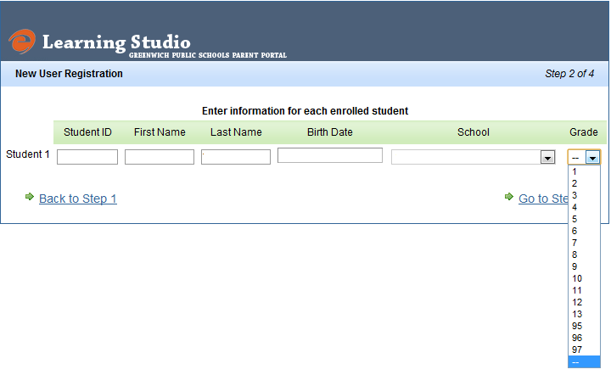drop-down list.

**NOTE:** PK3 = 95

PK = 96

K = 97

**COMPLETED INFORMATION**

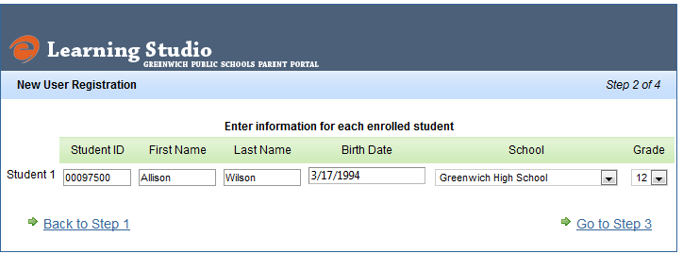This is an example of a completed student registration

Once you have completed the registration for all your students, *click Go to Step 3*

You will be asked to review an confirm the information you entered.

You will be asked to review and confirm the information you entered.

Once you have reviewed the information, click “Go to Step 4”.

**ERROR MESSAGE**

If the information you have entered does not match the student database, you will receive an error message as seen here.

You may click on Back to Step 2 to edit and correct any information.

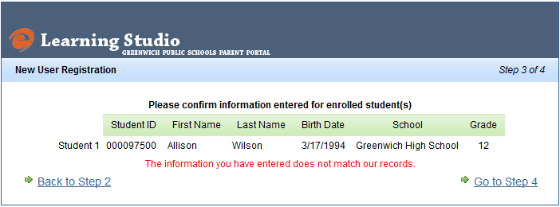

If after repeated tries, you are still unable to login you may call the helpdesk M-F from 7:00 AM – 3:00 PM when school is in session at 203 536 5240 or email the helpdesk at:

[Parent_portal@greenwich.k12.ct.us](mailto:Parent_portal@greenwich.k12.ct.us)

(parent_portal)

**STEP 5: Log-in, Read the Parent Portal Agreement and Complete Registration**

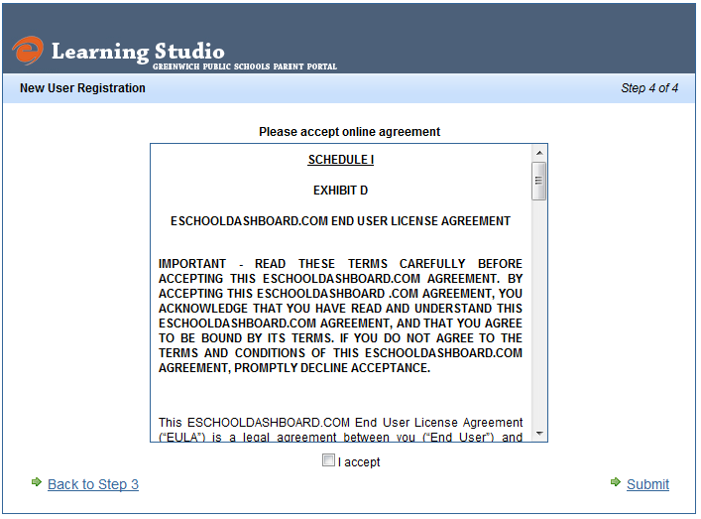**SUCCESSFUL LOGIN**

If your information is entered correctly you will be presented with an online agreement.

It is critical that you read the agreement.

Click the “I accept” box to accept the agreement.

Click the Submit button to complete your login.

You will be sent an email with a temporary password.

**STEP 6: Login to the new GPS Parent Portal for the First Time**

Check your Email for the temporary password

Access the Parent Portal Home Pageat - <https://parent.gsdteacherportal.com>

**User ID:** The email address used to create your account

**Password:** Temporary Password provided to you through your email.

Change your password to a strong password (at least 8 characters long and containing a number).

**STEP 7: Access the GPS Parent Portal At Any Time**



**User ID**: the email address used to create your account

**Password**: enter the password you created – it is at least 8 characters in length and contains a number.

C:\Users\jgunnip\AppData\Local\Microsoft\Windows\Temporary Internet Files\Content.IE5\IFTV5T2F\MC900240769[1].wmfIf you have forgotten your password, click the Forgot Password? Link to recover your information.

**NEED HELP?**

If you are experiencing any difficulties with the login process, you may call the following number during school hours: **203 536 5240**

You may email questions to:

[Parent_portal@greenwich.k12.ct.us](mailto:Parent_portal@greenwich.k12.ct.us)

(parent_portal)

Every attempt will be made to answer phone calls M-F from 7:00 AM to 3:00 PM when schools are in session.

An email response should be returned within 3 working days. Some delay may be experienced during high-volume periods such as the start of school.