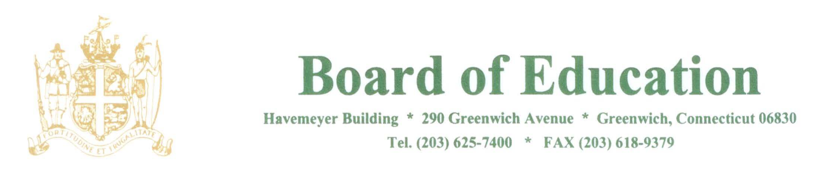

NOTICE OF MEETING

PLEASE POST

Notice is hereby given of the following meeting of the Policy Governance Committee of the Greenwich Board of Education to be held on December 13, 2017 at 3pm. This meeting will be held in the Board Room, Havemeyer Building, 290 Greenwich Avenue, Greenwich, CT.

The purpose of the meeting is to review policies.

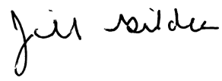
____________________
Dr. Jill Gildea
Superintendent of Schools

Rev. 12/7/17

