NOTICE OF CHANGE OF MEETING START TIME AND LOCATION

PLEASE POST

Notice is hereby given for the change of start time of the Meeting of the Board of Education Policy Governance Committee scheduled to be held on Wednesday, April 5 at 1:30pm in the Havemeyer Boardroom. The start time for the meeting has been changed to 7:30pm. The meeting will be held in the Havemeyer Staff Development Room.

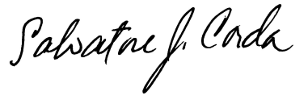
____________________
Dr. Salvatore Corda
Superintendent of Schools

SJC/lv
4/3/17

