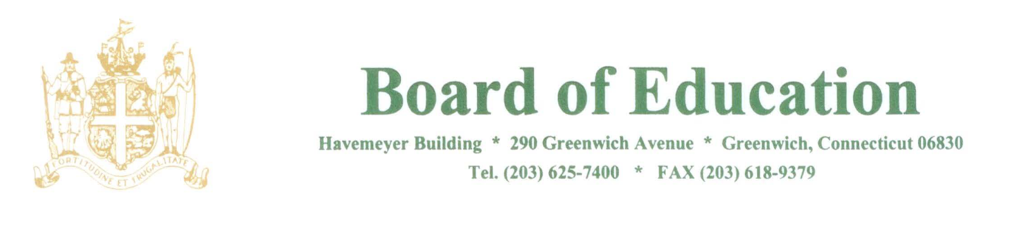

NOTICE OF MEETINGS

PLEASE POST

Notice is hereby given of the following changes to meetings of the Policy Governance Committee of the Greenwich Board of Education to be held on:

4-25-17 Tuesday – CANCELLED
4-27-17 Thursday – ADDED, 7PM
5-16-17 Tuesday – CANCELLED
5-18-17 Thursday – ADDED, 7PM
6-7-17 – CANCELLED
6-8-17 – ADDED, 8AM

All meetings will be held in the Board Room, Havemeyer Building, 290 Greenwich Avenue, Greenwich, CT.

The purpose of the meetings are to review policies.

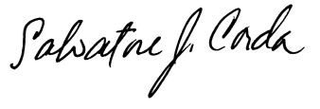
____________________
Dr. Salvatore Corda
Superintendent of Schools

SJC/lv
3/30/17

